2019
MIB Team
Bisrat Kidane
Robel Abraham
Fiqir Walle
Teklemariam (TK)
Blue Bank
11/22/2019

Blue Bank Specification

Main Concerns Of The Project

User Credentials
- For Customer:
username: guest
password: guest
- For Administrator:
username: admin
password: admin

Major Use-Cases
- Customer Feature:
Funds Transfer
Withdraw Funds
Deposit Funds
Send Funds from one account to another account

- Administrator Feature:
- Manage account with individual user who has an account.
Create Account
Update Account
Delete Account

Revision History

Date | Issue | Description | Authors
11/19/2019 | Sql prepopulate | Everything is done but it couldn’t execute the query, so we solved it by hard coding the data and make them populated when the application starts to run. | Bisrat, Robel, Fiqir,Teklemariam(TK)
11/19/2019 | Internationalization | No technical or coding problem but sometimes we had a problem when we run it in different machines | Bisrat, Robel, Fiqir,Teklemariam(TK)

Table of Contents
1. Introduction 4
1.1 Purpose 4
2. Requirements - Use-Case – Usage Scenarios 4
3. High Level Design 4
4. Detailed Design 5
4.1 <Object.Name> Usage 5
4.2 Interaction Diagram 5
5. Issues, Risk and Dependencies 5
6. Design Alternatives 5
7. References 5

- Introduction
  - Purpose
The purpose of this document is to describe functional and technical requirements for the banking system that should be developed by blue bank team. The proposed banking system is intended for the customers to do the transaction they want.
It will keep detailed accounting of all transactions for all accounts by all customers.
Overall Description
1.2.1. Product Perspective
The customer and the administrator will have a web based interface where they can access all subsidiaries services and accounts. When a customer accesses to the internet banking web site, a page is displayed for him to login and if credentials information is correct, he’s then taken to a user dash board where he has the entire transaction list that he can perform. At the same time, admin will login with his credential and will be taken to his own admin dash board but since admin can be a customer he can also view the user dashboard through his dash board.
1.2.2. Software Interface
- User on Internet : Web Browser, Operating System (any)
- Database Server : MYSQL for system
- Network : Internet
1.2.3. Communication Interface
- Any web browser (IE 6.0, Firefox, Opera, Google Chrome, etc.)
1.2.4. Product Features
The Blue Banking includes the following modules:
Customer Feature:
- Account Access(summary)
- Funds Transfer(
- Withdraw Funds
- Deposit Funds
- Send Funds from one account to another account
- Account details with all transaction history
Administrator Feature:
- Manage account with individual user who has an account.
Create Account
Update Account
Delete Account

1.2.5. Design and Implementation Constraint
- GUI is English, Amharic, Tigrigna(Internationalization)
- Login and password is used for user identification and admin identification and there is no facility for non user/admin to login
- Passwords are encrypted
- Create account/Update account has specific validations

- Requirements- Use Case – Usage Scenarios
In the Blue banking system the users are:
- Administrator
- Individual customer

- Administrator: user responsible for managing accounts and system users.

- Manage clients: The operational administrator assign new users when a new client joins the online bank. Also she/he can delete an account when a client leaves the bank.
- Individual customer: he can perform all transactions such as funds transfer, account view, deposit money, withdraw money and send money.

2.1. Some Use case Reports/Descriptions
1. Create Account /Customer in Blue Bank
System: Blue Bank | Group ID:
Use Case name: Create account and user details | UC ID:
Primary actor: Administrator | Priority (H,M,L):
Stakeholders: | UCP (Use Case Points):
Goal: Create account in Blue Bank
Trigger:
Relationships
􀂃 Association:
􀂃 Includes:
􀂃 Extends:
􀂃 Generalization:
􀂃 Extension points:

Input: group profile (mandatory), access type (consultation, transaction)
􀂃 Pre-conditions: Customer has been enrolled in BlueBank.

Normal (Basic) flow of events – Happy path –Successful path – Main Success Scenario
Steps:
Actor | System
- Operational administrator access to management module and found the open account button  - Operational administrator fills all the required fields | 2- System returns account enrollment form  8 4- System generates account and user information. System updates Blue Banking Data Base.
Post-conditions on success: account is generated and stored in Database

Output:
Test Cases:

2.Update account information
System: Blue Bank | Group ID:
Use Case name: Update account/user information | UC ID:
Primary actor: Administrator | Priority (H,M,L):
Stakeholders: | UCP (Use Case Points):
Goal: Change account/customer information
Trigger:
Relationships
􀂃 Association:
􀂃 Includes:
􀂃 Extends:
􀂃 Generalization:
􀂃 Extension points:

Input:
􀂃 Pre-conditions: customer and profile already created

Normal (Basic) flow of events – Happy path –Successful path – Main Success Scenario
Steps:
Actor | System
1- Admin accesses to Blue Bank and clicks on Edit button.  3-Admin changes information and click on “save” button. | 2- System returns account profile information.  8 4- System updates account/customer information.
Alternate and Exceptional flows:

Post-conditions on success: Account and Customer information are updated in Blue Bank database.
Post-conditions on failure: Record failure reason and date in Database
Output:
Test Cases:

Primary actor: Operational Administrator | Priority (H,M,L):
Stakeholders: | UCP (Use Case Points):
Trigger:

3.Transfer Funds (Transaction)
System: Blue Bank | Group ID:
Use Case name: Transfer Funds | UC ID:
Primary actor: Customer (Individual) | Priority (H,M,L):
Stakeholders: | UCP (Use Case Points):
Goal: Here the page will display transfer page for specific user’s account
Trigger: Customer access to Blue Bank web site
Relationships
􀂃 Association:
􀂃 Includes:
􀂃 Extends:
􀂃 Generalization:
􀂃 Extension points:

Input:
􀂃 Pre-conditions: Customer has logged in

Normal (Basic) flow of events – Happy path –Successful path – Main Success Scenario
Steps:
Actor | System
1-Customer clicks on “Transfer” button.  3-Customer choose the account types and enters amount. | 2-System shows a page to select from, to account type and amount of money he wants to transfer.  4-System returns to customer a page with transactions details and list of transactions he has done before.  - Transaction date,  - Transaction Type(Transfer)
Alternate and Exceptional flows:
-
Post-conditions on success: transaction detail will be stored in data base
Post-conditions on failure: -
Output:
Test Cases:

4.Withdraw/Deposit Funds (Transaction)
System: Blue Bank | Group ID:
Use Case name: Withdraw / Deposit Funds | UC ID:
Primary actor: Customer (Individual) | Priority (H,M,L):
Stakeholders: | UCP (Use Case Points):
Goal: Here the page will display Withdraw/Deposit page for specific user’s account
Trigger: Customer access to Blue Bank web site
Relationships
? Association:
? Includes:
? Extends:
? Generalization:
? Extension points:

Input:
? Pre-conditions: Customer has logged in

Normal (Basic) flow of events – Happy path –Successful path – Main Success Scenario
Steps:
Actor | System
1-Customer clicks on “Withdraw/Deposit” button.  3-Customer choose the account types and enters amount. | 2-System shows a page , to account type and amount of money he wants to withdraw.  4-System returns to customer a page with transactions details and list of transactions he has done before.  - Transaction date,  - Transaction Type(Withdraw/Deposit)  - Amount withdrew/deposited
Alternate and Exceptional flows:
-
Post-conditions on success: transaction detail will be stored in data base
Post-conditions on failure: -
Output:
Test Cases:

2.1. Blue Bank Functionality
  - .1 Account Accessing
Customer can view all accounts (checking, savings, credit card, Mobile, etc
FUNCTIONALITY | PROJECT STEP
- Account List  - Account summary | Step 1

2.1.2 Funds Transfer
In addition to viewing account information, customer may use Blue Bank to realize funds transfer. Customer may make one-time transfers. Customer may transfer funds among their checking accounts, savings accounts and Mobile .

FUNCTIONALITY | PROJECT STEP
- Funds Transfer inside (between all accounts) | Step 1

ACCOUNT TYPE | ACCOUNT VIEW | HISTORY | TRANSFER TO | TRANSFER FROM
Checking | X | X | X | X | X
Savings | X | X | X | X | X
Credit card | X | X | X |  | X

2.1.3. Security
FUNCTIONALITY | PROJECT STEP
- Admin Log in  - Customer log in | Step 1

2.1.4 Reports
FUNCTIONALITY | PROJECT STEP
- List of new access  - List of transaction activity | Step 1 and Step 2

High Level Design
Entities/Models
Domain Name | What Each Entity Does | Roles | Stereo Type
- Account  - AccountType  - Address  - Authority  - Transaction  - TransactionType  - User  - UserCredential | Holds all account information, account number, balance etc.  Holds Checking, Saving and credit  Holds city, address, street and state.  Holds username and authority  Holds transaction type, from account, to account and amount  Holds DEPOSIT, WITHDRAW,TRANSFER,SENT  Holds Customer information  Holds username, password and list of authorities | Account class  Specify types of accounts  It specifies customer’s address information  Roles as user and admin  Creates the transaction object used for processing all the transaction types  Specify types of transactions to be processed  Customer Object  Sets user name, password | Entity  Enum  Entity  Entity  Enum  Entity  Entity

Controller Name | What Each Controller Does | Roles | Stereo Type
- Account  - DepositAndWithDraw  - TransferAndSend  - SummaryAndDetail  - Home  - Login  - AccessDenied  - TestDB | Do all the Crud activities for the account.  Do deposit and withdraw mapping  Do Transfer and send mapping  Do account summary, account detail mapping  Do home page mapping  Do log in mapping  Do access denied mapping if failed to login  Do the prepopulating database mapping(helps in prepopulating of data) | class  class  class  class  class  class  class  class | Controller  Controller  Controller  Controller  Controller  Controller  Controller  Controller

N.B. The corresponding services and repositories are also well defined and designed.

4. Detailed Design

4.1 Class Diagram
Figure 2. High Level Design Diagram >

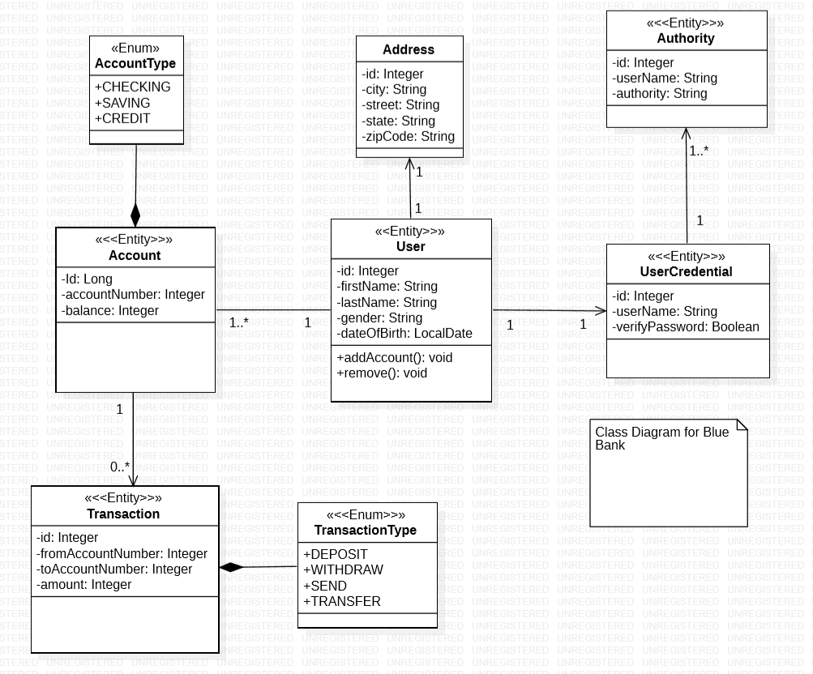

4.2. Sequence Diagram for Transfer fund(major use case)
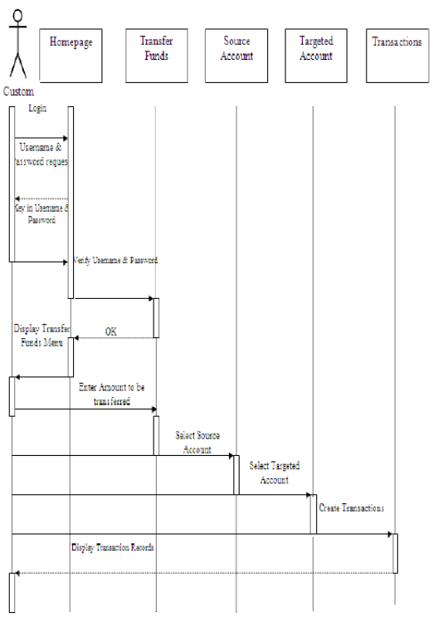
Architectural Design

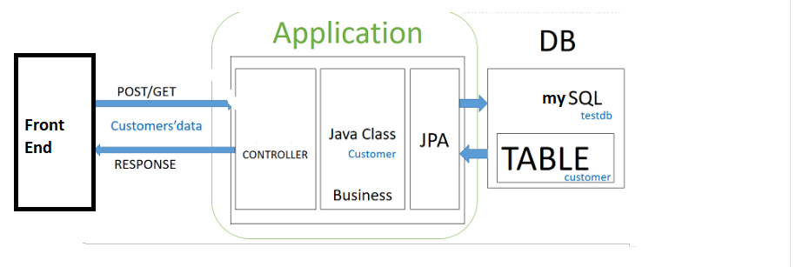

Sequence Diagram for Withdraw

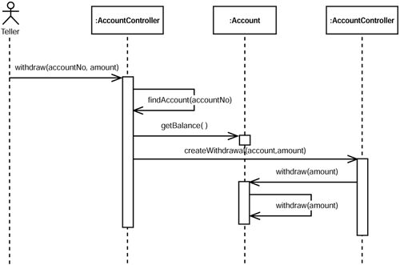

Issues, Risk and Dependencies
The main issues that happened during the development of the project were the internationalization like it works on one pc and it doesn’t work on others. Other issue was also the prepopulating data thing on which we took risks by hard coding data and make them saved ones the application runs.

Future Considerations

Feature | What is the feature about | Design improvement
- Block CreditCard  2 Credit card payment  - Retrieve pending payments  - Checkbook Request | Deactivate the card if it gets lost.  The customer can pay his credit card account in both currency dollars (USD).  The system allows customer and company to retrieve pending payments.  The system allows the customer to request checkbook | ---------  Sending message when he pays  shows confirmation message and generates receipt.

7. References

Refer to the Zipped project for the source code
USerCredentials
For Customer:
username: guest
password: guest
For Administrator:
username: admin
password: admin

Refer to the power point for the slide presentation.

Refer to the Task sheet excel for each team’s tasks and task hours.

THANK YOU!!!.

